

CRUD PROJECT

-------------------------------------------------------------------------------------------------------------------

Author Name

Sri mathi M

Junior Software Engineer

Mobileno:9952107695

Table Of Contents

Introduction: 2

Project description: 2

Scope: 2

Objective: 2

Software specification: 2

Data flow diagram: 3

1.User Module: 3

2.Admin Module: 3

Database and purpose: 4

1.External DB 4

2.AT Definition: 4

Testing: 4

1.Unit testing 4

2.Integration testing 4

Technical feasibility: 4

**1.**Admin module: 4

RequestDetails…………………………………………………………………………………………………………………6

HostDetails………………………………………………………………………………………………………………………7

Dailylog…………………………………………………………………………………………………………………….…….8

Report……………………………………………………………………………………………………………………………9

Priority: 10

2.User Module: 13

Password reset: 14

Change password: 14

STATION CONNECT DB: 16

Genealogy Architecture: 17

TRX:…………………………………………………………………………………………………………………………….18

MachineStatus:…………………………………………………………………………………………………..........19

Object:………………………………………………………………………………………………………………………….23

Error log: 29

Advantage: 2**9**

# Introduction:

CRUD refers to the four basic operations a software application should be able to perform – Create, Read, Update, and Delete.

# Project description:

CRUD PROJECT ensures that all employee activities and Equipment Status are tracked, providing total visibility and traceability into operations.

# Scope:

In such apps, users must be able to **create data**, have access to the data in the UI by **reading** the data, **update** or **edit** the data, and **delete** the data.

The API contains the code and methods, the database stores and helps the user retrieve the information, while the user interface helps users interact with the app.

# Objective:

* CREATE procedures: Performs the INSERT statement to create a new record.
* READ procedures: Reads the table records
* UPDATE procedures: Executes an UPDATE statement on the table based on the specified primary key for a record
* DELETE procedures: Deletes a specified row

# Software specification:

* 1.FTPC version - Process Designer 10.4
* 2.Sql version - SQL Server Management Studio 15.0.18404.0
* 3.Jasper studio version - TIBCO Jaspersoft® Studio Professional 8.1.0

# 

# Data flow diagram:

## **1.User Module:**

## **2.Admin Module:**

# 

# Database and purpose:

1.External DB **–** Time _Calculation

**External Table -**

CRUD_Calculation: Machine run Total minutes and seconds are logged

CRUD_User_MachineTime_Update: Update Machine start, end time and Total second

CRUD_User_Update_Split: Update machine start, End, Reason and Split seconds.

CRUD_Time_Calculation: Total run seconds with feedback and status.

## 

## 2.AT Definition

HostMap: Equipment is assigned with particular host.

Login_Details: All request accepts and reject details and total worked hours

Machine_Time: Machine status update if it gets end

User_Details: Every user logged info, login, logout, shift wise worked hours

User_Request: All pending request is logged in this table

# Testing:

## 1.Unit testing

* + - Login details log when multi user log
    - Machine start time log when machine multiple get start

## 2.Integration testing

* + - Manual logout and auto logout when shift end
    - Manual machine time end and auto end when shift end

# Operation feasibility:

* Access Privilege
* Application
* Area
* AT Definition
* DCS Definition
* Equipment and class
* Image
* List
* Production line
* Route, Route operation
* Station
* Subroutine
* User, User group
* Work instruction
* TRX
* Work Schedule

# Technical feasibility:

## 1.Admin module:

Login with admin name and password.

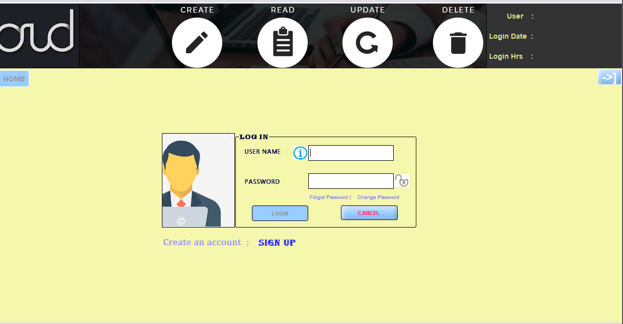

Request details will be available in grid when click details automatically fix related. If admin give approve.

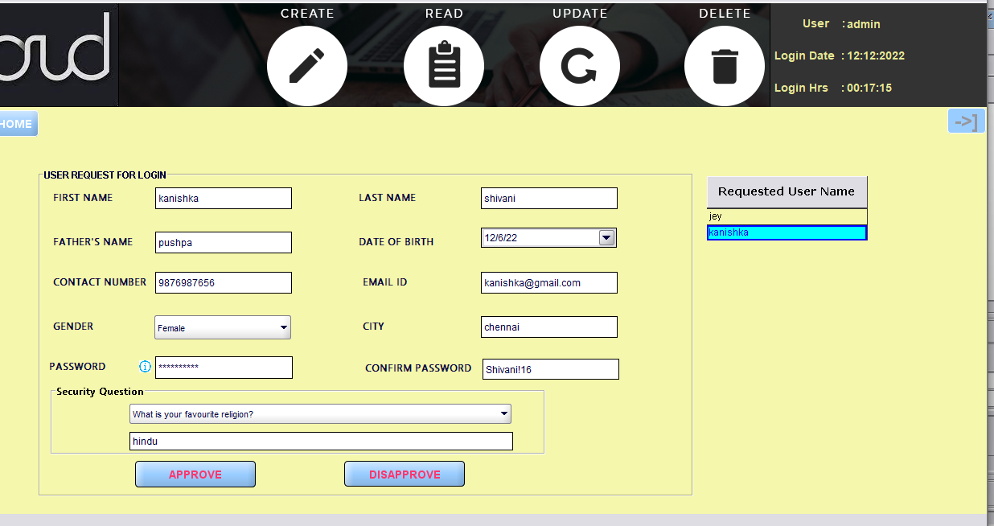

## Daily User Log

## Host Area Mapping:

Equipment maps in to host:

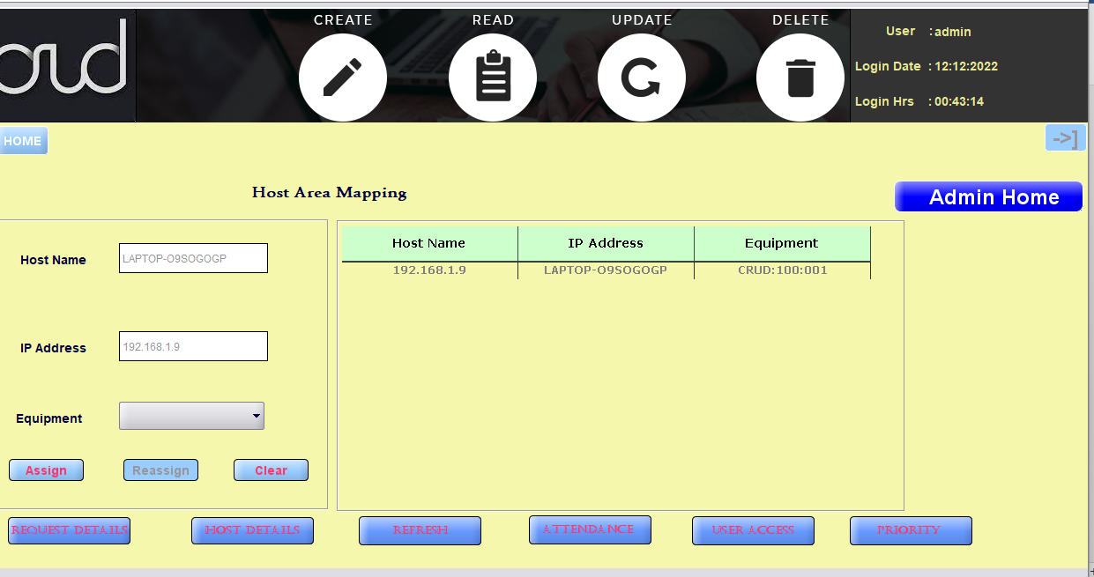

## Attendance:

Name wise or ShiftWise or date wise filter

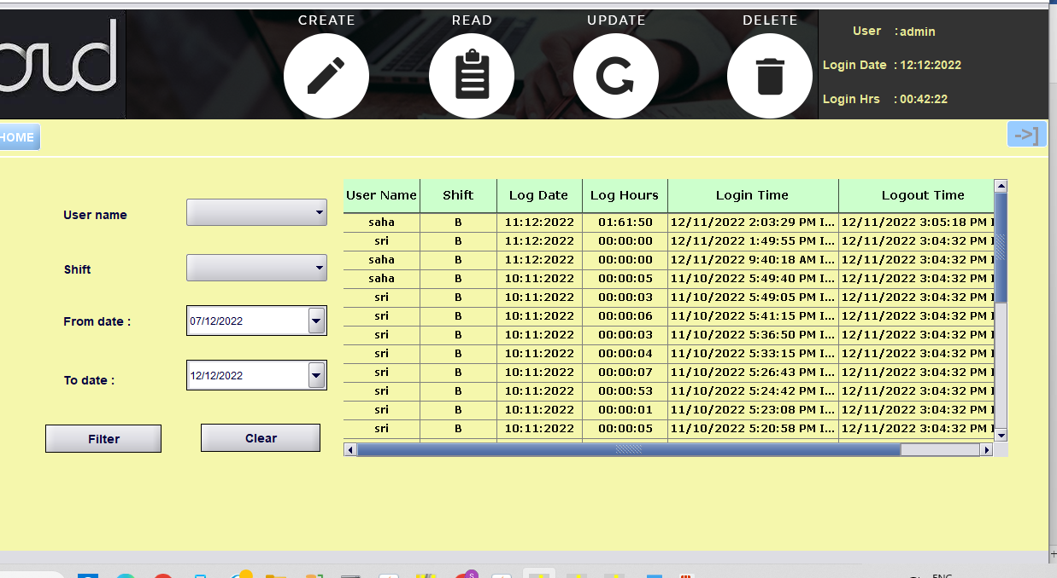

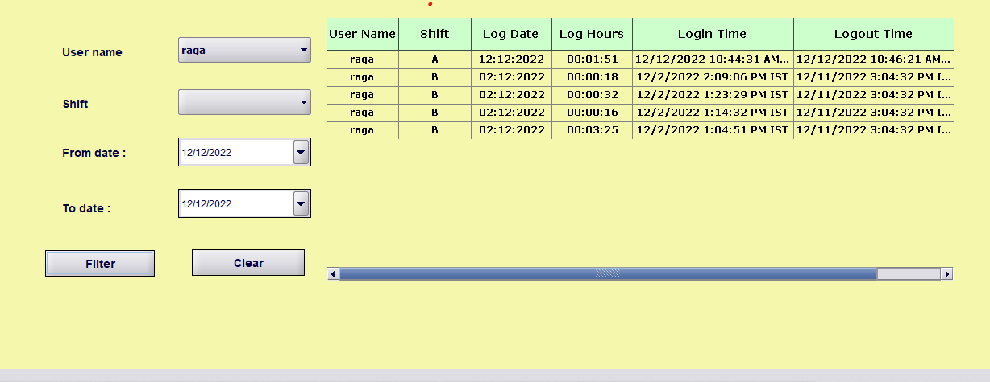

## Report:

Create report of all user:

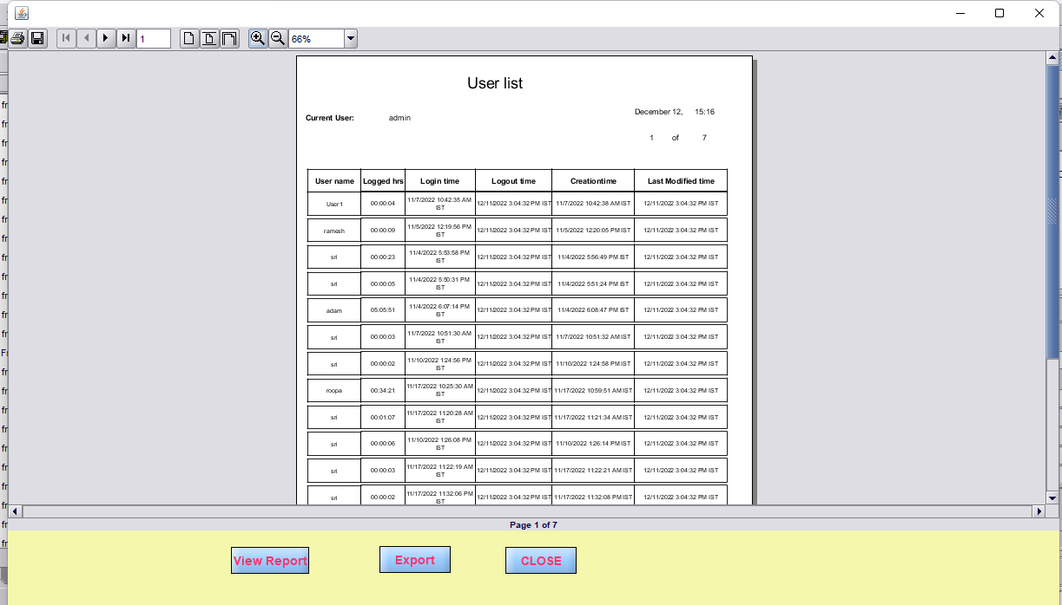

Chart Based upon user and access privileges:

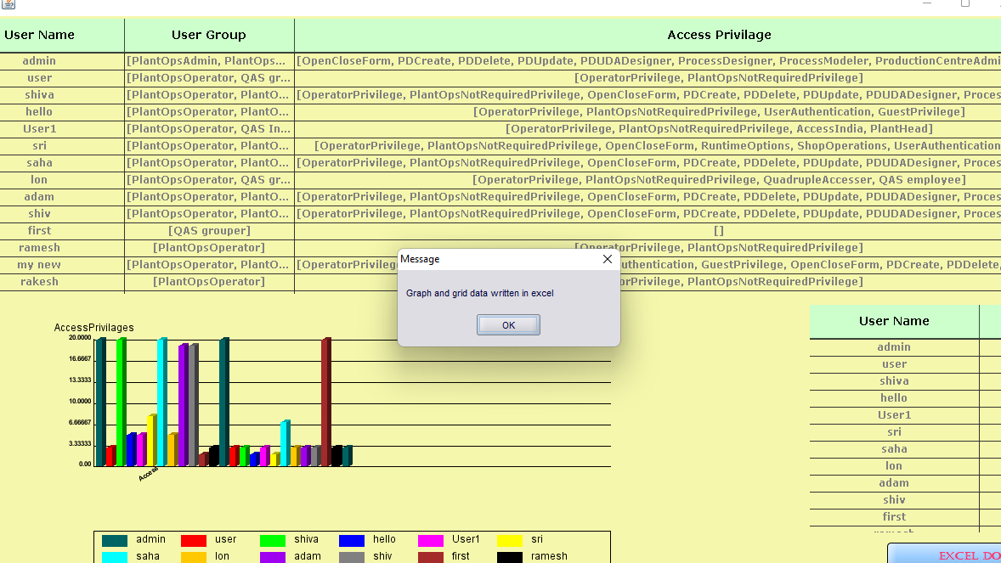

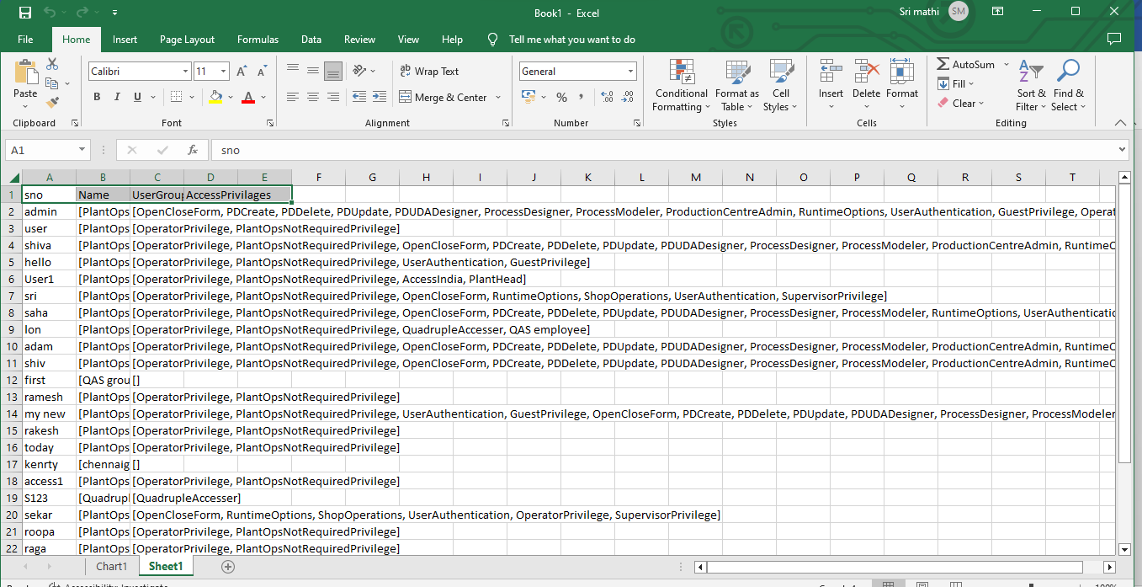

## Priority:

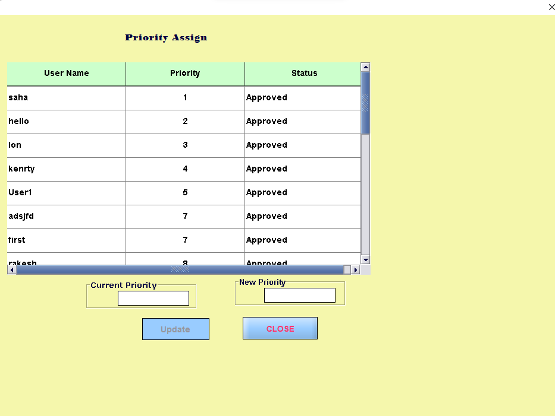

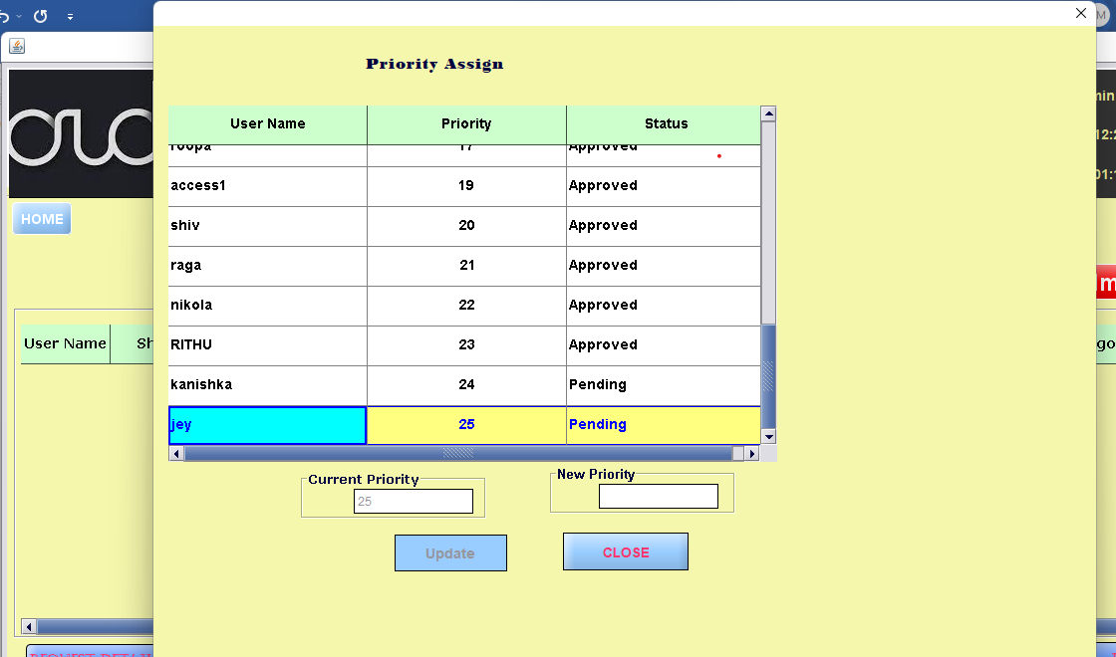

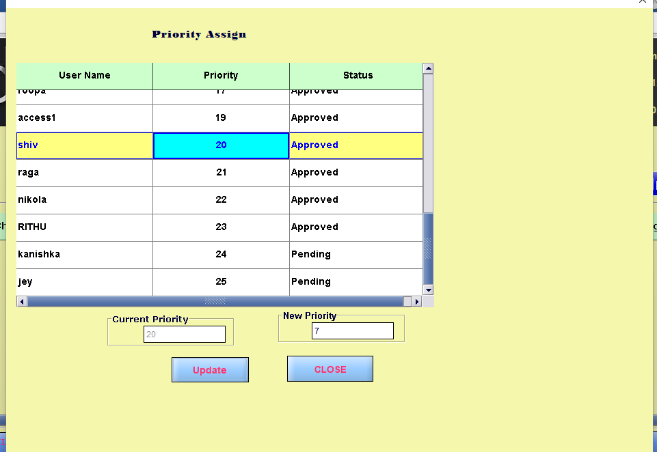

Priority 20 comes into 7th place already presented 7th is incremented by 1.

## Host Area Mapping:

## User Approve/Disapprove/Pending:

Admin did not check user request

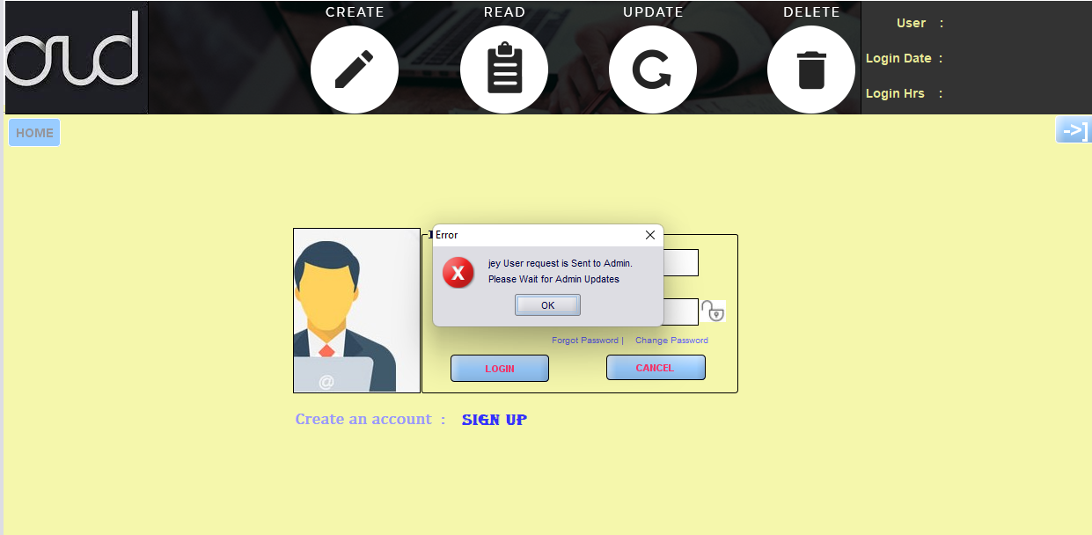

### Pending:

If user try to login within half an hour user status will be in pending. Login after 30 minutes message will come

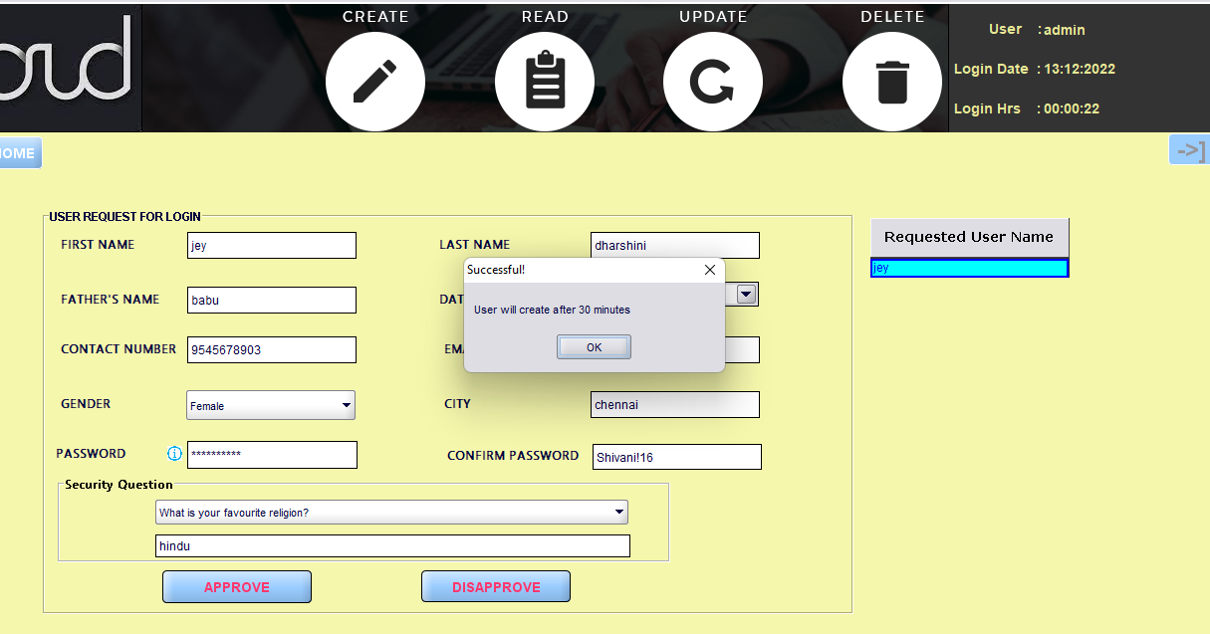

Approve:

When User try to login immediately after approve.

## 2.User Module:

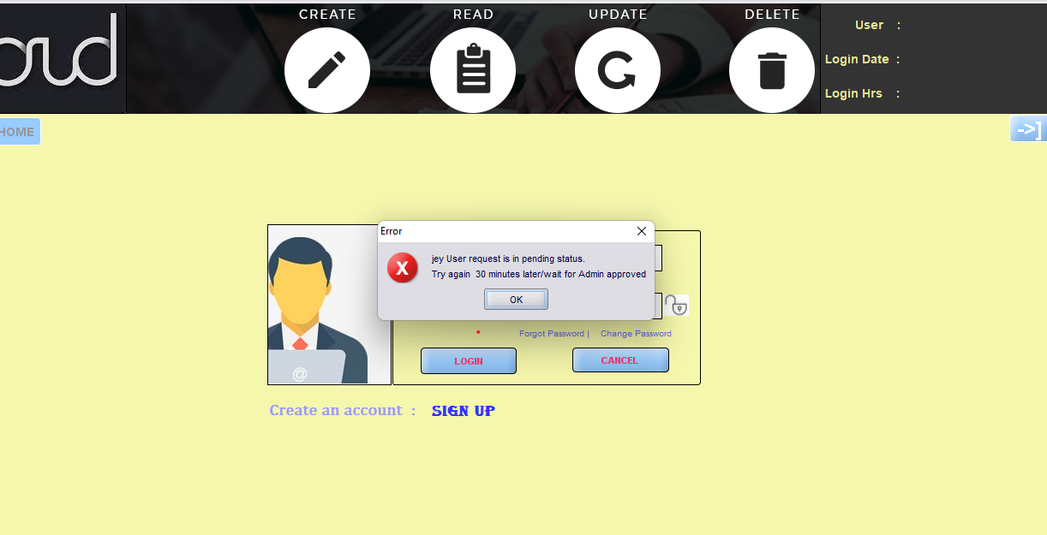

### Signup:

For Signup User request page click SIGNUP

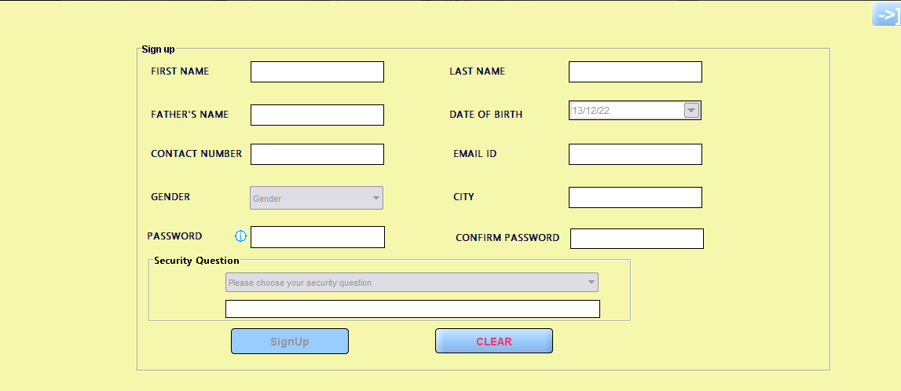

After half an hour when user login with their password it will login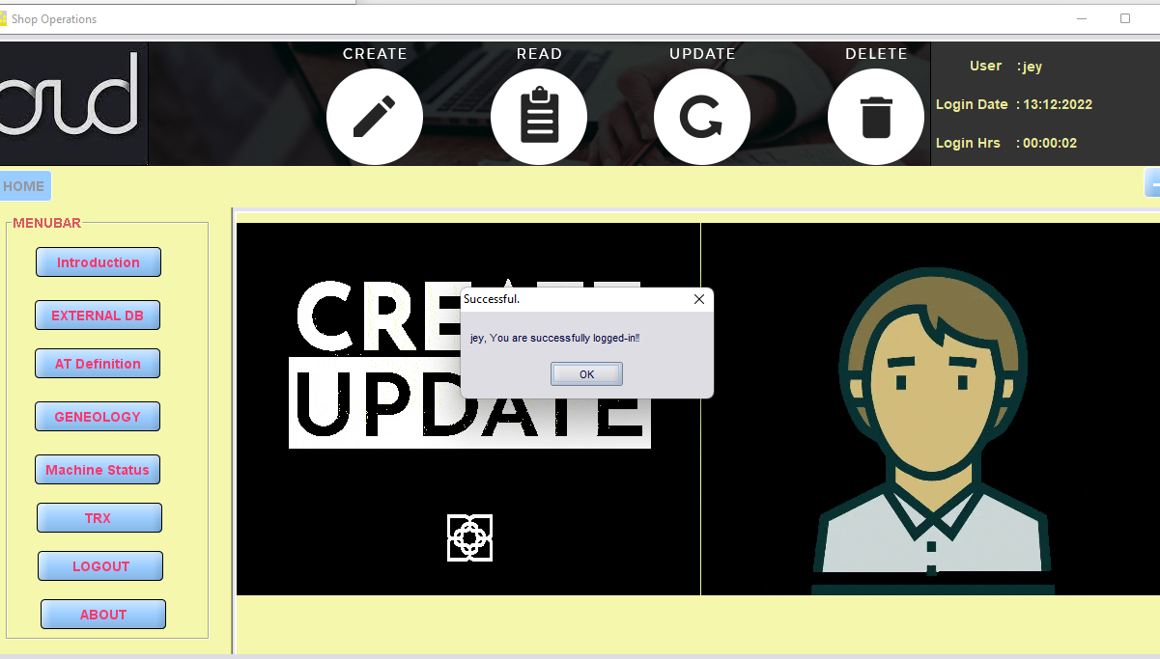

### Password reset:

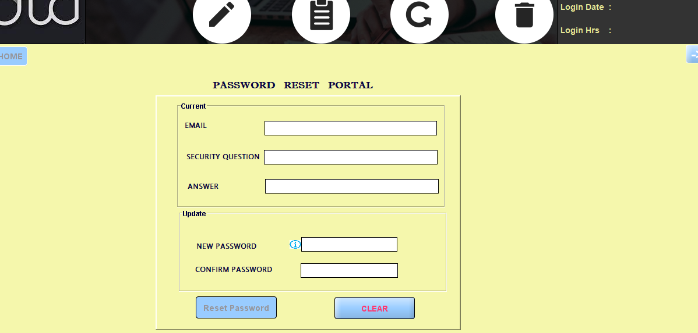

### 

### Change password:

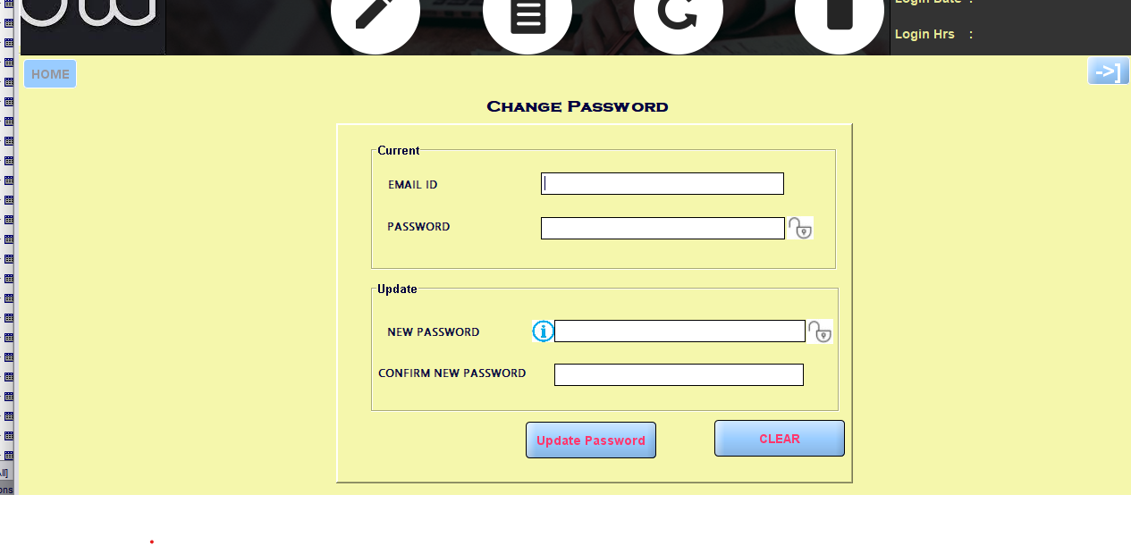USER PAGE INTRODUCTION:

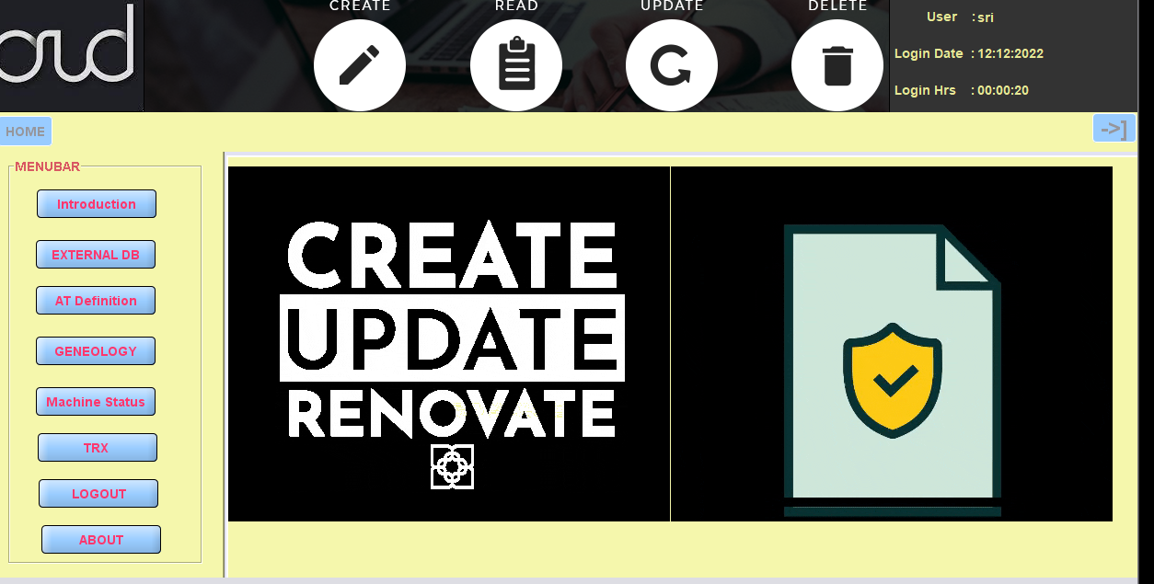

### STATION CONNECT DB:

### 

### STATION DISCONNECT DB:

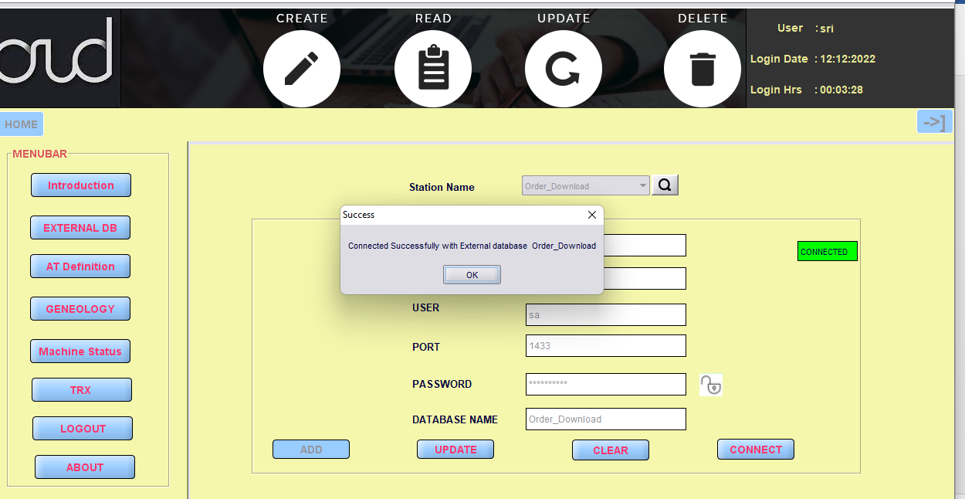

# Genealogy Architecture:

## Genealogy Admin:

## Genealogy user:

### All user group:

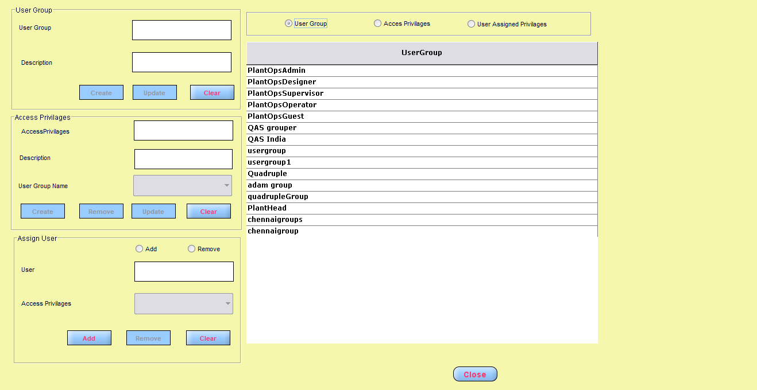

### All Accessprivilages user group details:

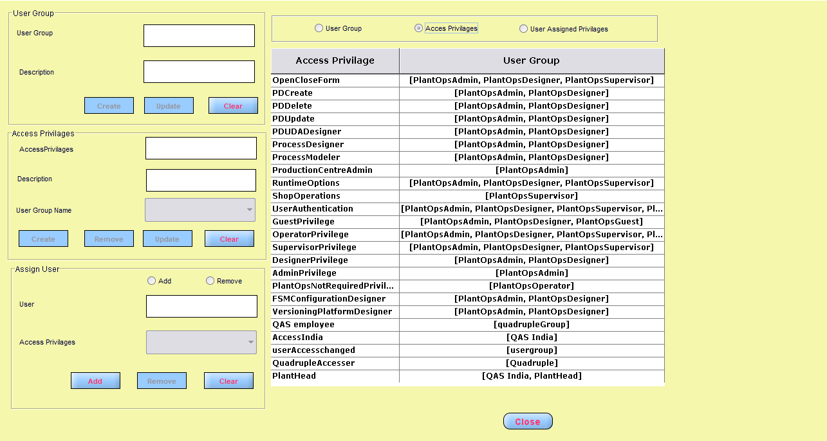

All user and their groups and their access privileges:

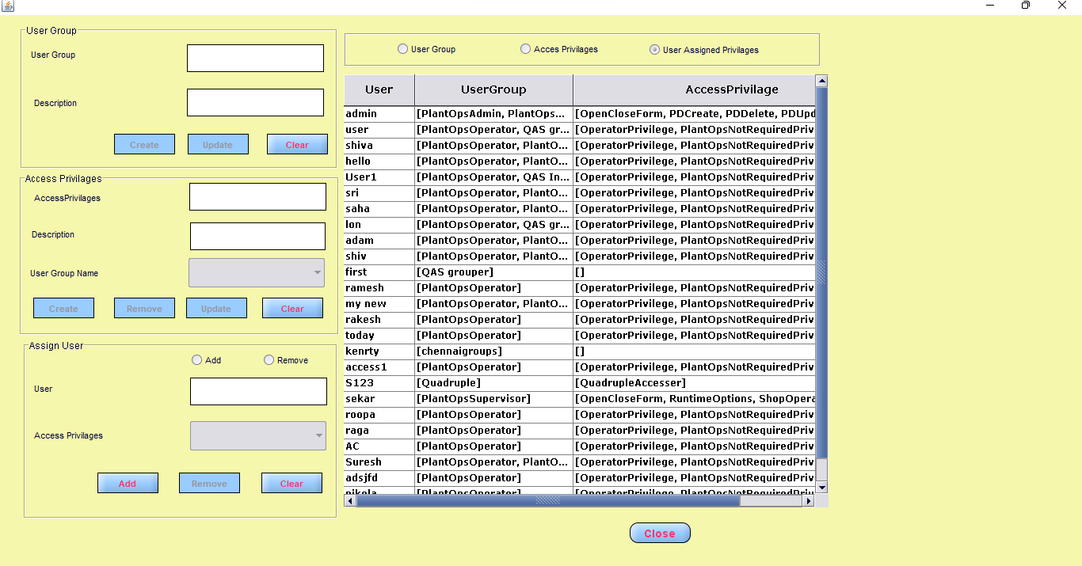

## Machine Status:

If particular machine is in running status that machine not start again.

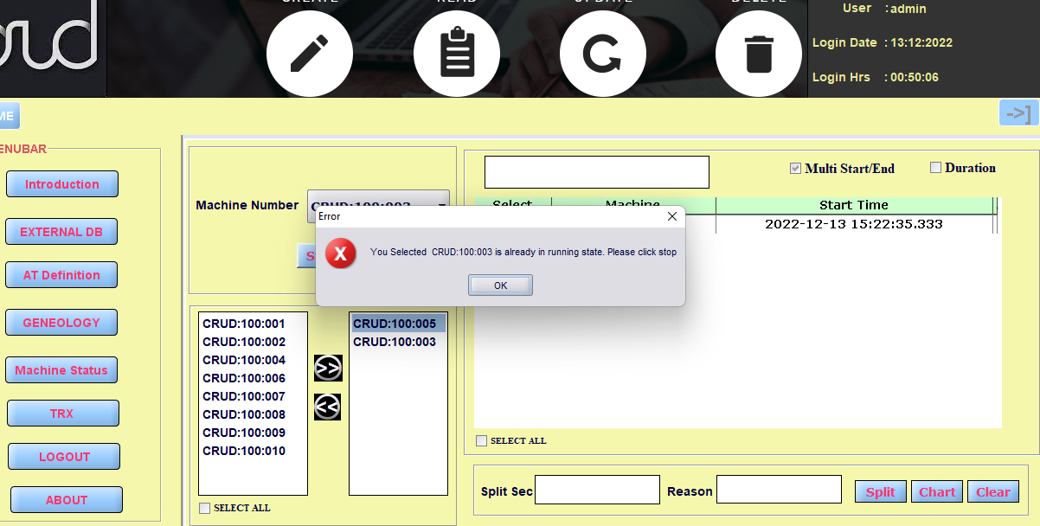

Multi Start/End check box for multiple machines start and end. Select All checkbox for run all equipment.

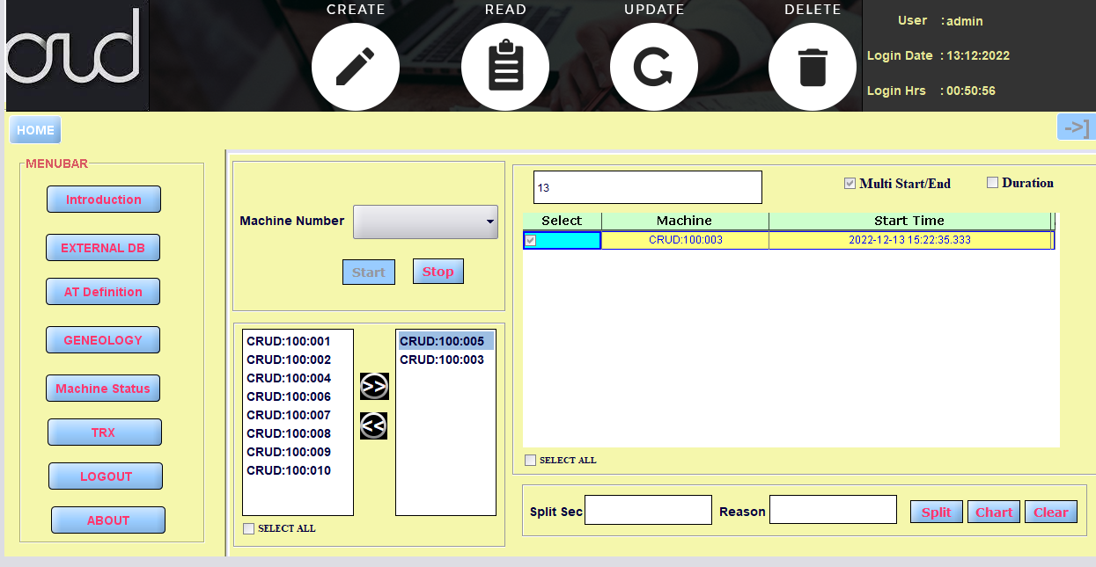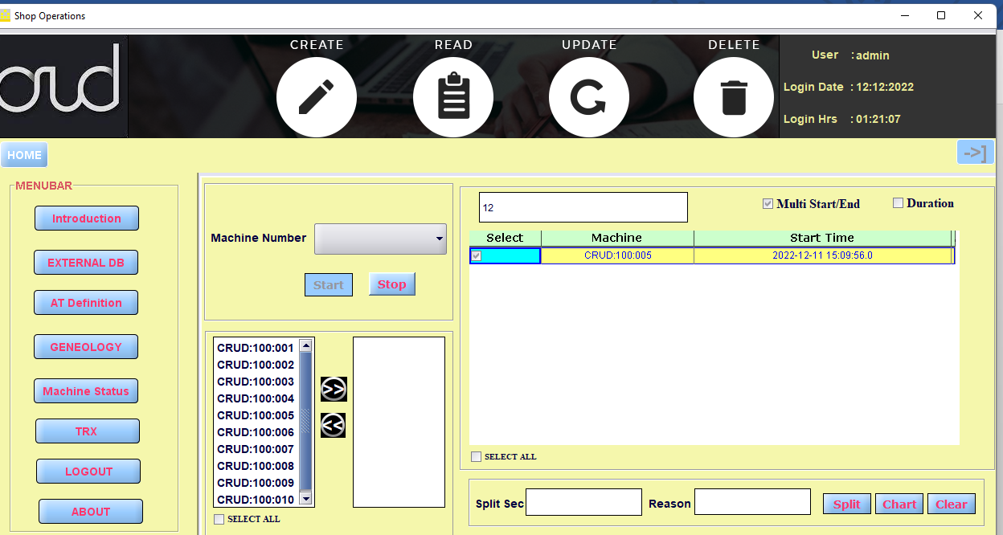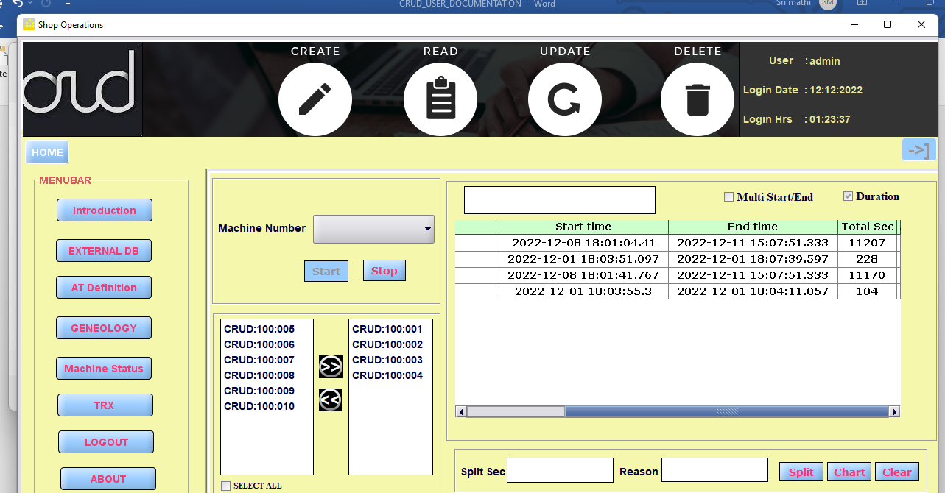

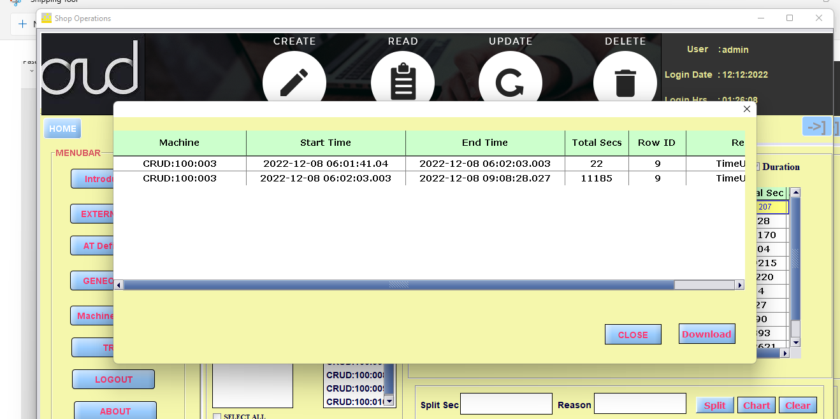

When click download. Data write into excel.

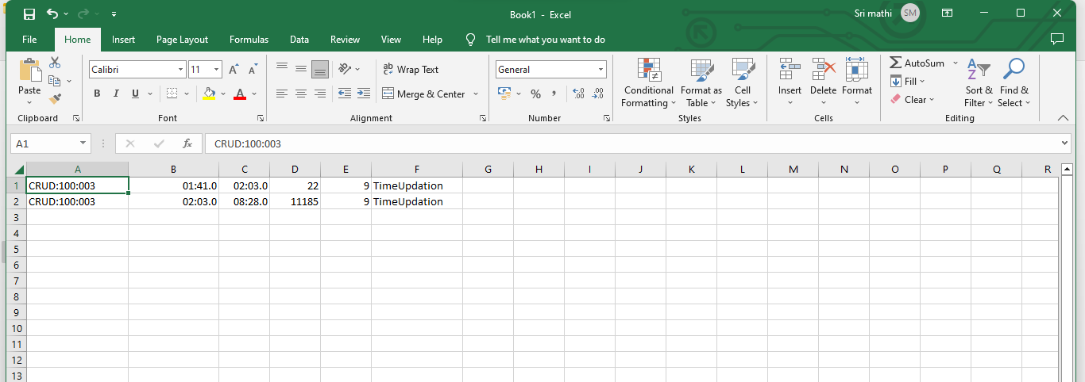

Machine wise total run time chart

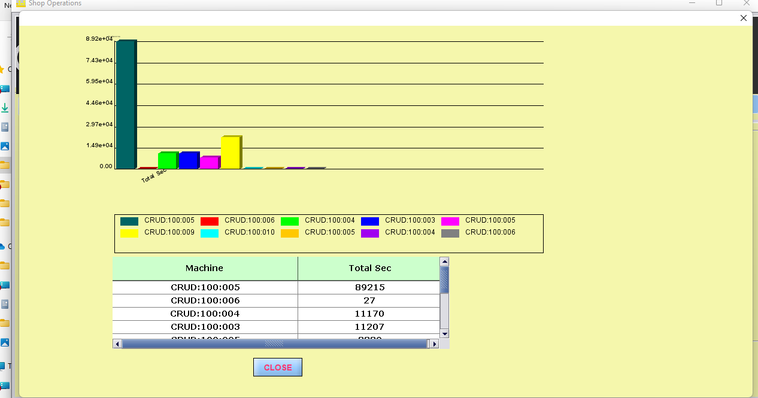

## TRX:

All TRX table added in combo when click table name all column displayed in grid. Based upon column value Top 10 displayed in table.

## 

Transaction base filter details is displaying

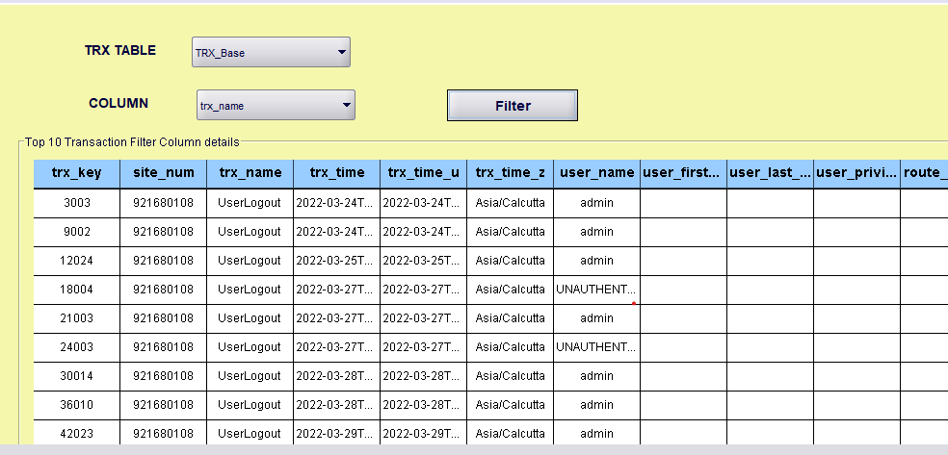

## Object:

In about all object descriptions are added into the documents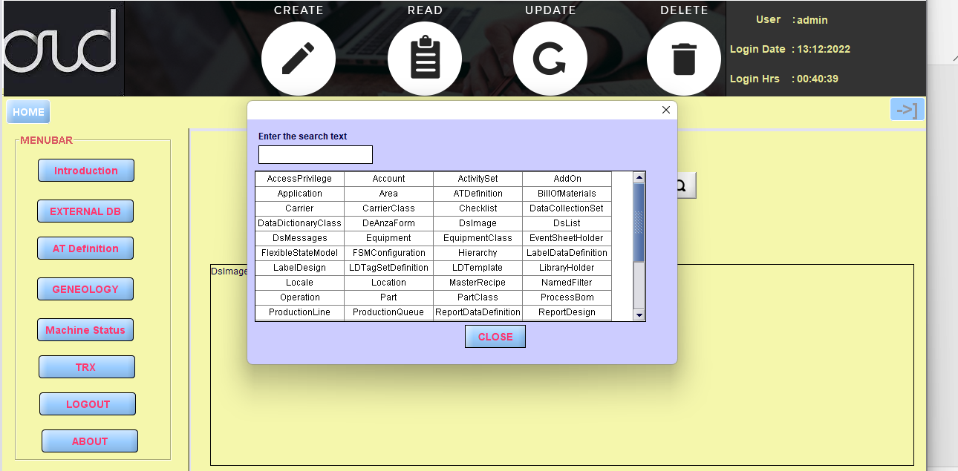

### Info:

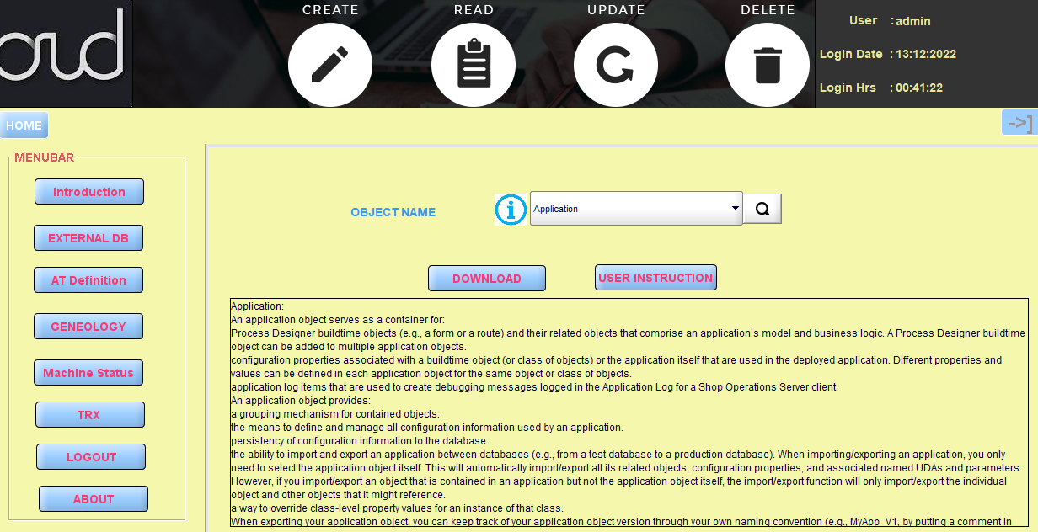

### User Instruction:

When click user instruction PDF file will open. Click open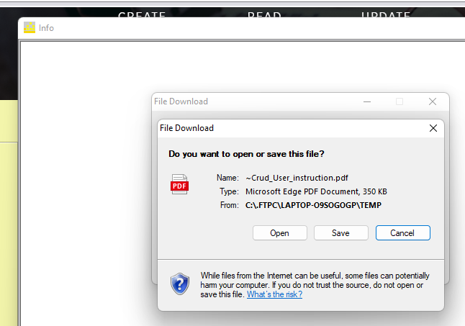

User guide is given for that module

### Download: C:\.FTPC\LAPTOP-O9SOGOGP\TEMP\~Crud_User_instruction.pdf

### In text format

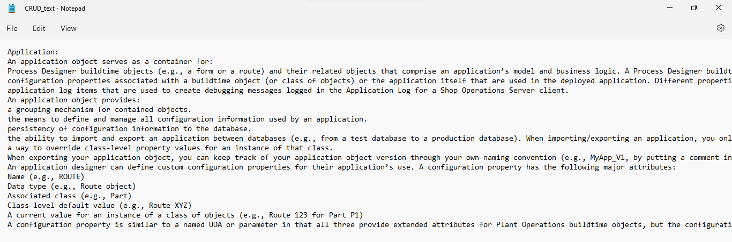

#### In PDf format:

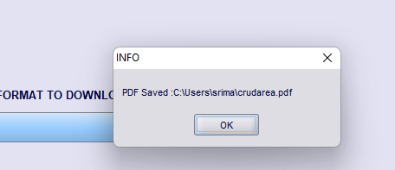

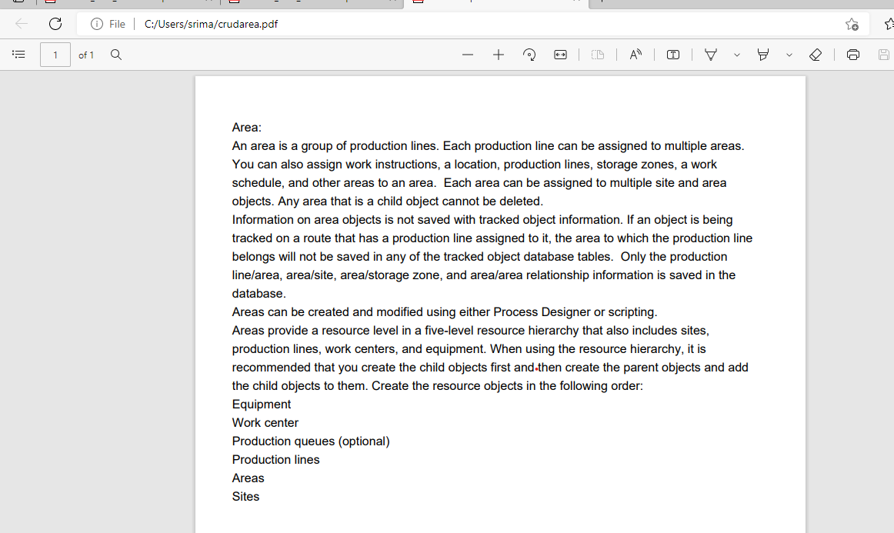

### AT DEFINITION:

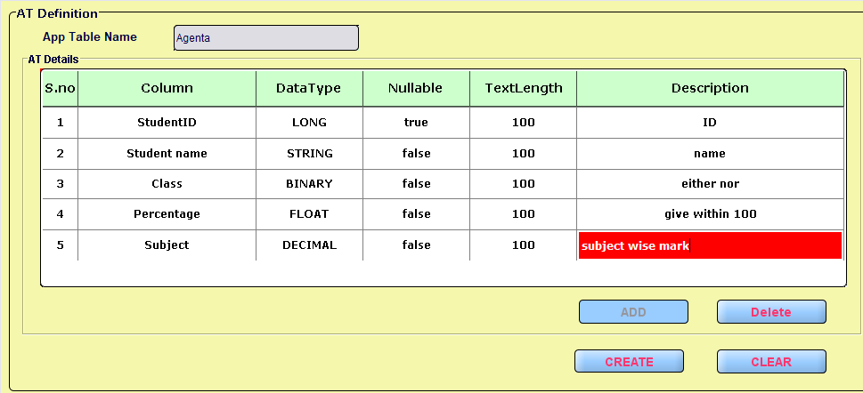

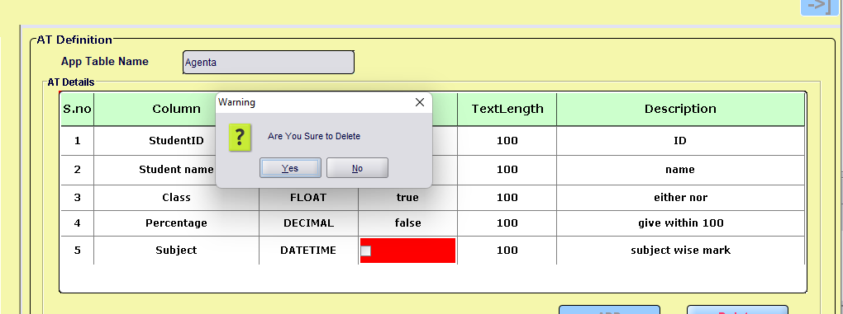  
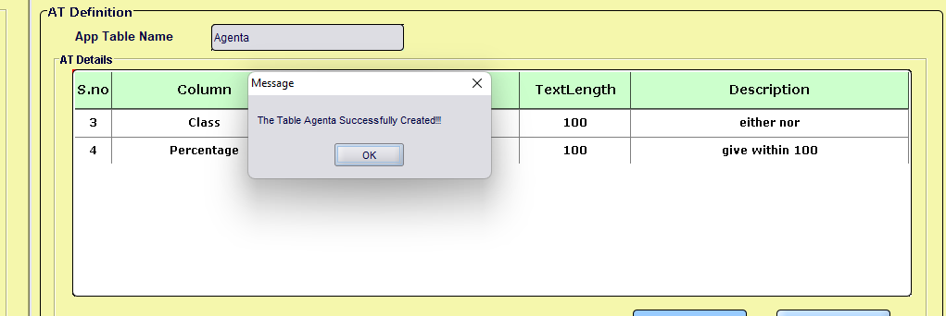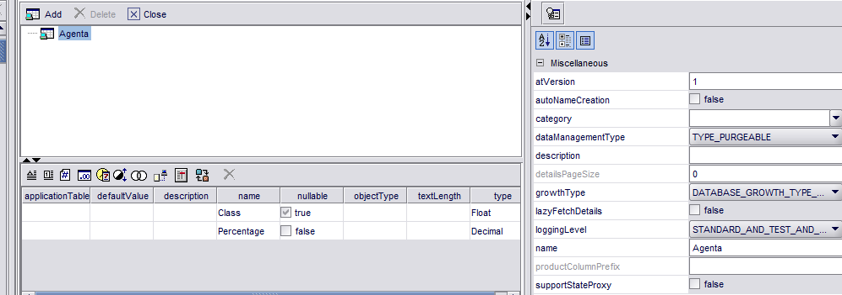

# Error log:

All types of error are logged into text file.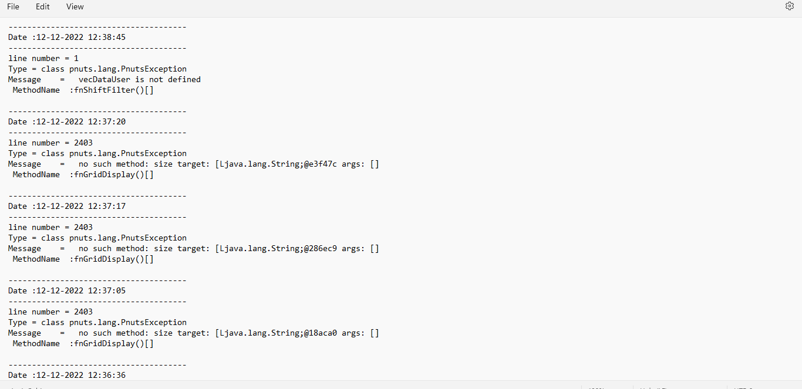

# Advantage:

* Productivity increase
* Survival tool (Chart and Report)o
* **Productivity evaluation.**
* **Assess real company needs.**
* Supervision and managements